JKSS COLLEGE

“O” LEVEL PROJECT WORK

WEB PAGE ON INDIAN FESTIVAL

REGISTRATION NO: 1018097

LEVEL: O

NAME: SOMDUTT DWIVEDI

FATHER`S NAME: BIJAY KUMAR DWIVEDI

***ACKNOWLEDGEMENT***

***We are using this opportunity to express our gratitude to everyone who supported us throughout the course of this O’Level project. We are thankful for their aspiring guidance, invaluably constructive criticism and friendly advice during the project work. We are sincerely grateful to them for sharing their truthful and illuminating views on a number of issues related to the project***

***We are highly indebted to JANKALYAN SHIKSHA SANSTHAN for their guidance and constant supervision as well as for providing necessary information regarding the project & also for their support in completing the project.***

***Our thanks and appreciations also go to our colleague in developing the project and people who have willingly helped me out with their abilities.***

***Thank You,***

***INTRODUCTION***

***This is Project is on Indian Festivals.***  Festivals are a time for bonding; a time for cross-cultural exchange; a time to forgive and forget. India, being a secular country does not have any state religion. The state of India allows for freedom of faith, worship & religion. People of many different religions live in our country. They are free to follow & preach the religion of their choice. Among the major religion in India, Hinduism is the largest, followed by Islam, Christianity, Sikhism, Buddhism, and Jainism & Zoroastrianism.

It is Lohri in the north, Bihu in the east, Pongal in the south, or Ganesh Chaturthi in the west, the fervors of festivities is infectious and what were once considered regional celebrations, are today a cause for exuberance all over the country. The latest to be given national recognition is the festival of Chhath, formerly restricted only to Bihar. In fact India can probably claim to have the maximum number of holidays in the world for festivals.

.

**INDEX**

1*.* Home Page

2. About Festival

3. Festival Page

4. Gallery Page

5. Page Developed By

6. January

7. February

8. March

9. April

10. May

11. June

12. July

13. August

14. September

15. October

16. November

17. December

HOME PAGE

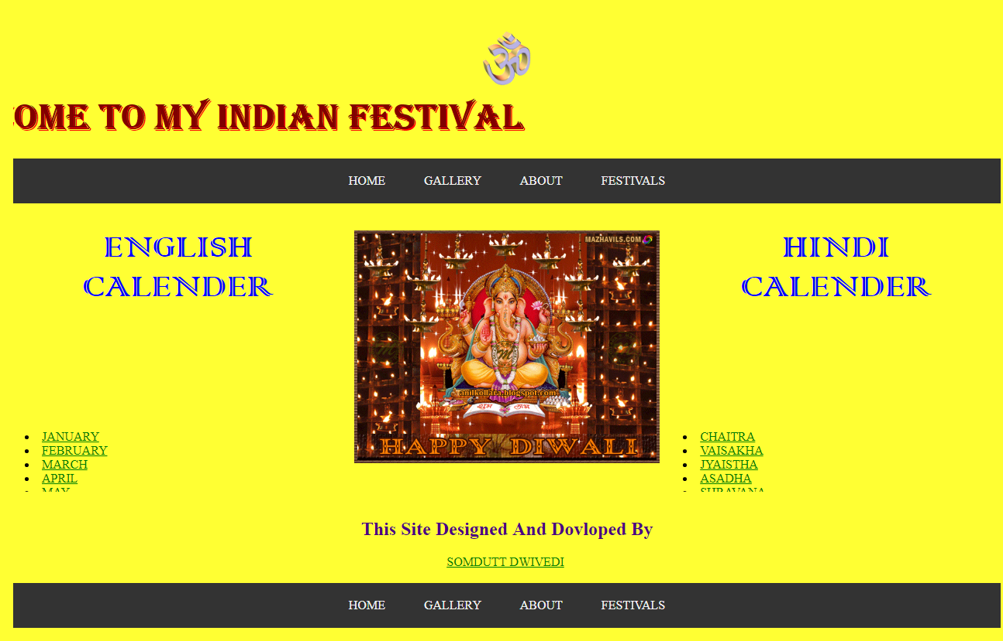

HOME PAGE

<html>

<head>

<title>festival</title>

</head>

<body bgcolor="orange">

<table border="1" bordercolor="#800000"><tr><th><a href=" HOME PAGE.html"><font color="800000" size="3">HOME</th></tr></table>

<center><img src="om.gif" width="62" height="70"></center>

<h1><center><font face="Comic Sans MS" color="blue" size="30"> indian festival</font></center></h1>

<center><img src="2.jpg" width="40%"height="60%"></center>

<center><table width="80%">

<tr>

<th >

<h3><p><b><font color=" blue">India is a land of festivals, where people from different religions coexist harmoniously. The wide variety of festivals celebrated in India is a true manifestation of its rich culture and traditions. There are many Indian festivals and celebrations, the most exciting of which are mentioned below. While the celebrations happen all over the year, October till January is the time when the country can be seen at its vibrant best.</font><p></b></h3>

<h2><u><i><font color="green">List of Indian Festivals: The widely celebrated religious festivals in the country</h2></font></i></u></center>

<font color="white" size="15">1. DIWALI</font>

<br>

<img src="diwali.jpg"width="80%"height="100%">

<br><h3><p><b><font color=" blue">Diwali, one of the most prominent Hindu festivals of India, is celebrated with a lot of pomp and show. During this festival of lights, houses are decorated with clay lamps, candles, and Ashok leaves. People wear new clothes, participate in family puja, burst crackers, and share sweets with friends, families, and neighbors.</font>

<br>

<font color="white" size="15">2. HOLI</font>

<br>

<img src="holi.jpg"width="50%"height="50%">

<br><h3><p><b><font color=" blue">Also known as the festival of colors, holi is one of the famous festivals of India, celebrated with a lot of fervor across the country. On the eve of Holi, people make huge Holika bonfires and sing and dance around it. On the day of Holi, people gather in open areas and apply dry and wet colors of multiple hues to each other, with some carrying water guns and colored water filled balloons.

<BR>

Significance: It signifies the victory of good (Prince Prahlad) over evil (Holika) and the arrival of spring.

<BR>

Key attractions: Holika bonfire, playing with colors, and bhang thandai

<BR>

When: Full moon (Purnima) of the Phalgun month of the Hindu lunisolar calendar, which corresponds to the month of March of the Gregorian calendar

<BR>

Where: Almost all over the country; most vibrant celebrations can be seen in North Indian states

<BR>

Holi 2017: 12th March</font>

<br>

<font color="white" size="15">3. DUSSHERA</font>

<br>

<img src="dus.jpg"width="50%"height="50%">

<br><h3><p><b><font color=" blue">Dussehra, also referred to as Vijayadashami, is also among the most famous festivals of India. It is celebrated in different forms countrywide. Ramlila(enactment of scenes from Ramayana) is held everywhere for 10 days. It’s culminated with “Ravan Dahan” – the burning of huge effigies of Ravana, Meghnath and kumbhakaran which is a real spectacle to see.

<BR>

Significance: It celebrates the death of the demon king Ravana at the hands of Lord Rama.

<BR>

Key attractions: Hustle bustle of the decorated markets, Ram-leela acts, and the big event of the burning of effigies of Ravana, Meghnad, and Kumbhakaran

<BR>

When: 10th day of the month of Ashwin according to the Hindu lunisolar calendar, which corresponds to September or October of the Gregorian calendar

<BR>

Where: Pan India

<BR>

Dussehra 2017: 30th September</font>

<br>

<font color="white" size="15">4. NAVRATRI</font>

<br>

<img src="Navratri.jpg"width="50%"height="20%">

<br><h3><p><b><font color=" blue">Navratri festival is celebrated by all people throughout India in different ways. In Gujarat, it is a nine day celebration of rejuvenating Garba nights and highly energetic Dandiya Raas dances. People are dressed in beautiful, colorful traditional clothes and the environment is very youthful and invigorating.

<BR>

Significance: It represents the celebration of the Goddess Amba (Power) in nine different forms.

<BR>

Key attractions: The 9 days of dance festivities in Gujarat, the exquisite Chaniya Choli’s (traditional skirt & blouse), and the Gujarati cuisine – Sabudana Khichdi, Mandavi Paak, Singoda ki Kheer, and Potato Wafers

<BR>

When: The first nine days of the month of Ashwin according to the Hindu lunisolar calendar, which correspond to September or October of the Gregorian calendar

<BR>

Where: Almost all over the country; most vibrant in Gujarat, Maharashtra and the metros

<BR>

Navratri 2017: Begins on 21st September</font>

<br>

<font color="white" size="15">5. DURGAA PUJA</font>

<br>

<img src="DURGA.jpg"width="50%"height="20%">

<br><h3><p><b><font color=" blue">One of the important Hindu festivals of India, Durga Puja is celebrated with grandeur by Bengalis, throughout the country. The 10 days of fast, feast, and worship of Goddess Durga are accompanied by cultural songs, dances, and dramas. Huge and beautiful Durga idols are made and placed in specially made artistic Pandals(canopies). People dress in traditional wear and go around the pandal – hopping, praying, and feasting.

<BR>

Significance: It commemorates Lord Rama’s invocation of Goddess Durga before going to war with the demon king Ravana.

<BR>

Key attractions: Plush pandals, incredibly beautiful ten armed Durga idols, and the puja

<BR>

When: 10th day of Ashwina shukla paksha according to the Hindu lunisolar calendar, which corresponds to September or October of the Gregorian calendar

<BR>

Where: Kolkata and the metros are the best places to be in India during Durga Puja celebrations

<BR>

Durga Puja 2017 Begins on 26th September</font>

<br>

<font color="white" size="15">6. KRISHNA JANMASTMI</font>

<br>

<img src="Janm.jpg"width="70%"height="20%">

<br><h3><p><b><font color=" blue">Janmashtami is again a beautiful one among the most important religious festivals of India. Janmashtami celebrations in Mathura and Vrindavan are very popular. People fast throughout the day and break it with a special meal after dusk. Visiting temples, praying, dancing, and singing bhajans (hymns) at midnight is a part of the celebrations of the birth of Lord Krishna. Often, small children dress up like Lord Krishna on this day. Images and picturization of Krishna’s life story are depicted in the “jhaankis” in temples.

<BR>

Significance: It is the annual celebration of the birthday of Lord Krishna.

<BR>

Key attractions: The Janmashtami puja and festivities in the temples and the jhaankis of Lord Krishna

<BR>

When: The 8th day (Ashtami) of the Krishna Paksha (dark fortnight) of the month of Bhadrapad according to the Hindu lunisolar calendar, which corresponds to August or September of the Gregorian calendar

<BR>

Where: Celebrated by the Hindu community all over, but the festivities at Mathura and Vrindavan are very popular

<BR>

Janmashtmi 2017: 15th August</font>

<br>

<font color="white" size="15">7. GANESH CHATURTHI</font>

<br>

<img src="Ganesh.jpg"width="80%"height="20%">

<br><h3><p><b><font color=" blue">Ganesh Chaturthi, another one of important Hindu religious festivals of India, is a 10-day affair of colorful festivities. Huge handcrafted Ganesh idols are installed in homes or outdoors, in public pandals. Pujas are performed in the morning and the evening. The last day is the day of Visarjan – immersion of an idol in a water body. Cultural activities of singing, dancing, and theater, and free medical and blood donation camps are held.

<BR>

Significance: It’s the birthday of Lord Ganesha, the elephant-headed God.

<BR>

Key attractions: The beautifully crafted life size idols of Ganesha, and the immersion ceremony

<BR>

When: The 4th day of the first fortnight (Shukla Chaturthi) in the month of Bhadrapada of the Hindu lunisolar calendar, which corresponds to August or September of the Gregorian calendar

<BR>

Where: Celebrated in the states of Maharashtra and Andhra Pradesh with fervor and gaiety

<BR>

Ganesh Chaturthi: 5th September</font>

<br>

<font color="white" size="15">8. GURU PURB</font>

<br>

<img src="gurupurab.jpg"width="100%"height="20%">

<br><h3><p><b><font color=" blue">On the most important Sikh festival of India, special assemblies on the lives and teachings of the gurus, and langars (community meals) are organized in the gurudwaras. Karah Prasad is distributed among all, and hymn chanting processions are held in the city. People light up their homes with lamps and candles and burst crackers to celebrate Gurpurab.

<BR>

Significance: It is the celebration of the anniversaries of the ten Sikh Gurus.

<BR>

Key attractions: The soulful Bhajan-Kirtan (hymns), Gurbani in the Gurdwaras, the Langar and the Karah Prasad

<BR>

When: The full moon day in the month of Kartik of the Hindu lunisolar calendar, which corresponds

to November of the Gregorian calendar

<BR>

Where: Celebrated by the Sikh community all over the world, especially in Punjab

<BR>

Gurupurab 2017: 5th January</font>

<br>

<font color="white" size="15">9. RAKSHA BANDHAN</font>

<br>

<img src="rakhi.jpg"width="60%"height="7%">

<br><h3><p><b><font color=" blue">One of the famous festivals of India, Rakhi is celebrated among Hindu. Signifying the brother-sister bonding, during Rakhi, the sister performs Aarti (prayer), applies tilak, and ties rakhi (a sacred thread) on the brother’s wrist wishing his well being. The brother, in return, vows to protect the sister. Another festival which has strong similarity to Rakhi is Bhaidooj which comes just after Diwali.

<BR>

Significance: It symbolizes the strong bonding of a brother and sister.

<BR>

Key attractions: The ritual of Rakhi and the brightly decked up markets showcasing a colourful variety of rakhis and sweets

<BR>

When: The full moon day of Shravana month of the Hindu lunisolar calendar, which corresponds to August of the Gregorian calendar

<BR>

Where: Particularly in North, Central and West India

<BR>

Rakshabandhan 2017: 7th August</font>

<br>

<font color="white" size="15">10. EID- UL- FITRA</font>

<br>

<img src="eid.JPG"width="60%"height="7%">

<br><h3><p><b><font color=" blue">Eid is one of the major festivals of India for the Muslim community. People dress up in fineries, attend a special community prayer in the morning, visit friends, and relatives and exchange sweets. Children are given idi(money or gift) by elders.

<BR>

Significance: It celebrates the conclusion of the holy month of fasting called Ramadan.

<BR>

Key attractions: The beautifully decked up markets and mosques, the morning Eid namaz at the mosques, and the sweet dishes.

<BR>

When: On the 1st day of the month of Shawwal of the lunar Hijri calendar, which corresponds to July of the Gregorian calendar

<BR>Where: Celebrated by Muslims all over the country

<BR>

Eid Ul Fitr 2017: 26th June</font>

<br>

<font color="white" size="15">11. BIHU</font>

<br>

<img src="bihu-festival.jpg"width="60%"height="5%">

<br><h3><p><b><font color=" blue">Popular among the festivals of India celebrated in the North East, Bihu is the harvest festival of Assam. During the month-long celebrations, young men and women wear their traditional clothes and perform the Bihu dance in the village fields and courtyards. A community feast is held with a lot of fanfare.

<BR>

Significance: It’s the traditional new year celebration of Assamese.

<BR>

Key attractions: The Bihu dance and the local cuisine – coconut laddoo, til pitha, ghila pitha, and fish pitika

<BR>

When: 14th or 15th April

<BR>

Where: Celebrated by the Assamese diaspora around the world, especially in Assam

<BR>

Bihu 2017: Begins on 14th April</font>

<br>

<font color="white" size="15">12.HEMIS</font>

<br>

<img src="hemis-fesival.jpg"width="60%"height="5%">

<br><h3><p><b><font color=" blue">Hemis, the two-day religious festival from Ladakh, is one of the important festivals of India. It attracts a lot of locals and foreign tourists each year. The festivities include the Cham dance done by the priests to the tune of the traditional music of cymbals, drums, trumpets played by the monks. The dancing priests dress up in elaborate brocade outfits and masks.

<BR>

Significance: It’s the celebration of the birth anniversary of spiritual leader Padmasambhava, founder of Tibet Tantric Buddhism.

<BR>

Key attractions: The scenic Hemis monastery and the Cham dance

<BR>

When: 10th day (called Tse-Chu in the local language) of the Tibetan lunar month, which corresponds to June or July of the Gregorian calendar

<BR>

Where: Ladakh, Jammu & Kashmir

<BR>

Hemis 2017: Begins on 23rd June</font>

<br>

<font color="white" size="15">13. ONAM</font>

<br>

<img src="onam.jpg"width="60%"height="5%">

<br><h3><p><b><font color=" blue">Onam is among the important festivals of India, wherein people wear traditional wear, adorn houses with Pookalam (floral designs), and prepare Onasadya(elaborate meal of 11/13 dishes). Events such as Vallamkali(snake boat race), Kaikottikali(clap dance), Kathakali dance, and Pulikali procession(artists dressed and painted like tigers and hunters) are held.

<BR>

Significance: It celebrates the homecoming of the legendary king Mahabali.

<BR>

Key attractions: The spectacular Snake Boat Race, the enigmatic Kaikottikali dance, and the Elephant procession

<BR>

When: In the month of Chingam of the Malayalam calendar, which corresponds to August or September of the Gregorian calendar

<BR>

Where: Celebrated by people of all communities in the state of Kerala.

<BR>

Onam 2017: Begins on 25th August

</font>

<br>

<font color="white" size="15">14. PONGAL</font>

<br>

<img src="pongal.jpg"width="60%"height="4%">

<br><h3><p><b><font color=" blue">The four-day long harvest festival of South India is one of the most famous festivals of India. People prepare Pongal dish and wear their traditional attire. Celebrities include bonfires, dance, cattle races, sweets, and savories. The houses look resplendent with Kolam designs (traditional floral designs made with rice, colored powders, and flower petals)

<BR>

Significance: It’s a festival of thanksgiving to nature representing the first harvest of the year.

<BR>

Key attractions: The variety of Kolam designs and cattle races

<BR>

When: 14th or 15th January

<BR>

Where: Celebrated by Tamils all over India, primarily in Tamil Nadu

<BR>

Pongal 2017: Begins on 13th January</font>

<br>

<font color="white" size="15">15. Christmas</font>

<br>

<img src="christmas-tree-and-firplace.jpg"width="60%"height="4%">

<br><h3><p><b><font color=" blue">One of the most famous and awaited festival in the world, Christmas happens to be of sheer significance for elders and children alike. Everyone regardless of their religion wait for this day, children specifically for the surprise gifts from Santa. All the churches are lit up and decorated to celebrate the birth of Lord Jesus.

<BR>

Significance: Birthday of Lord Jesus

<BR>

Key attractions: Christmas tree decoration, prayers, birth of Lord Jesus and Santa Claus

<BR>

When: 25th December

<BR>

Where: The festival is celebrated across India. The best places to celebrate Christmas in India are Goa, Pondicherry, and Kerala.

<BR>

Christmas 2017: 25th December</font>

**ABOUT FESTIVAL PAGE**

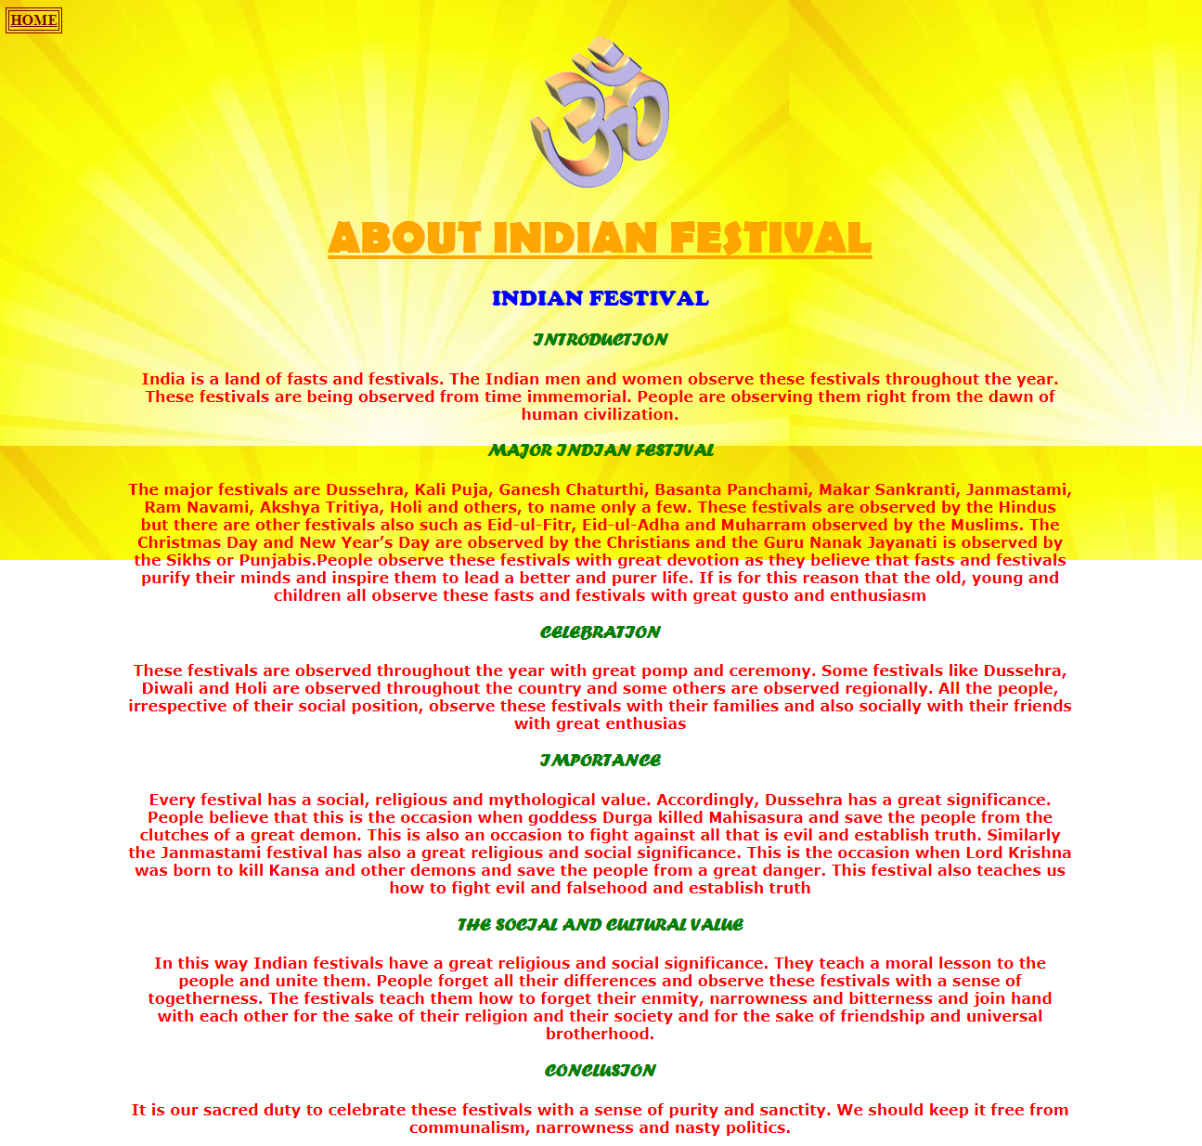

ABOUT INDIAN FESTIVAL

<html>

<head>

<title>about us</title>

</head>

<body background="img7.jpg" width="100%"height="100%">

<table border="1" bordercolor="#800000"><tr><th><a href=" HOME PAGE.html"><font color="800000" size="3">HOME</th></tr></table>

<center><table width="80%">

<tr>

<th>

<center><img src="om.gif"><br>

<h1><u><font face="Berlin Sans FB"color="orange"size="15">ABOUT INDIAN FESTIVAL</font></u></h1></center>

<font face="Cooper" color="blue">

<h2> INDIAN FESTIVAL </h2></font>

<font face="Forte"color="green">

<h3>INTRODUCTION</H3>

<b><font face="Verdana" color="RED">

India is a land of fasts and festivals. The Indian men and women observe these festivals throughout the year. These festivals are being observed from time immemorial. People are observing them right from the dawn of human civilization.<br>

<font face="Forte"color="green">

<h3>MAJOR INDIAN FESTIVAL</H3></font>

The major festivals are Dussehra, Kali Puja, Ganesh Chaturthi, Basanta Panchami, Makar Sankranti, Janmastami, Ram Navami, Akshya Tritiya, Holi and others, to name only a few. These festivals are observed by the Hindus but there are other festivals also such as Eid-ul-Fitr, Eid-ul-Adha and Muharram observed by the Muslims. The Christmas Day and New Year’s Day are observed by the Christians and the Guru Nanak Jayanati is observed by the Sikhs or Punjabis.People observe these festivals with great devotion as they believe that fasts and festivals purify their minds and inspire them to lead a better and purer life. If is for this reason that the old, young and children all observe these fasts and festivals with great gusto and enthusiasm<BR>

<font face="Forte"color="green">

<h3>CELEBRATION</H3></font>

These festivals are observed throughout the year with great pomp and ceremony. Some festivals like Dussehra, Diwali and Holi are observed throughout the country and some others are observed regionally. All the people, irrespective of their social position, observe these festivals with their families and also socially with their friends with great enthusias</BR>

<font face="Forte"color="green">

<h3>IMPORTANCE</H3></font>

Every festival has a social, religious and mythological value. Accordingly, Dussehra has a great significance. People believe that this is the occasion when goddess Durga killed Mahisasura and save the people from the clutches of a great demon. This is also an occasion to fight against all that is evil and establish truth. Similarly the Janmastami festival has also a great religious and social significance. This is the occasion when Lord Krishna was born to kill Kansa and other demons and save the people from a great danger. This festival also teaches us how to fight evil and falsehood and establish truth<BR>

<font face="Forte"color="green">

<h3>THE SOCIAL AND CULTURAL VALUE</H3></font>

In this way Indian festivals have a great religious and social significance. They teach a moral lesson to the people and unite them. People forget all their differences and observe these festivals with a sense of togetherness. The festivals teach them how to forget their enmity, narrowness and bitterness and join hand with each other for the sake of their religion and their society and for the sake of friendship and universal brotherhood.</BR>

<font face="Forte"color="green">

<h3>CONCLUSION</H3></font>

It is our sacred duty to celebrate these festivals with a sense of purity and sanctity. We should keep it free from communalism, narrowness and nasty politics.

</th>

</tr></table></body></html>

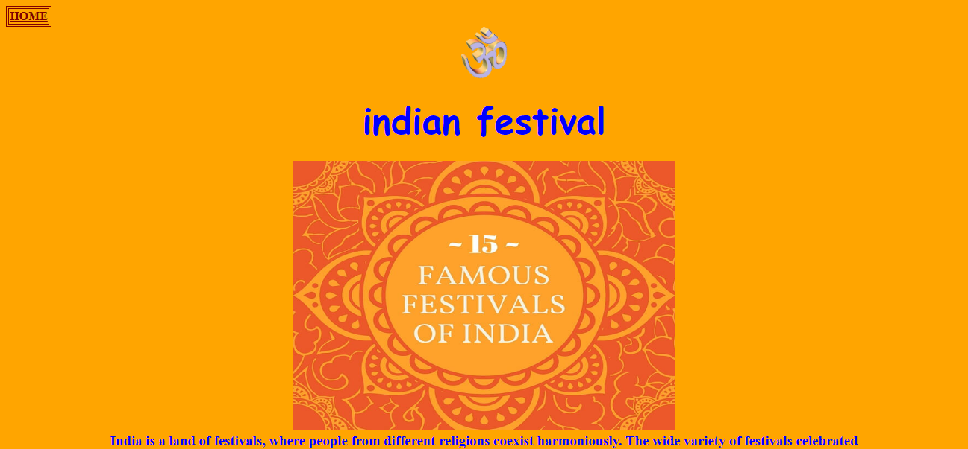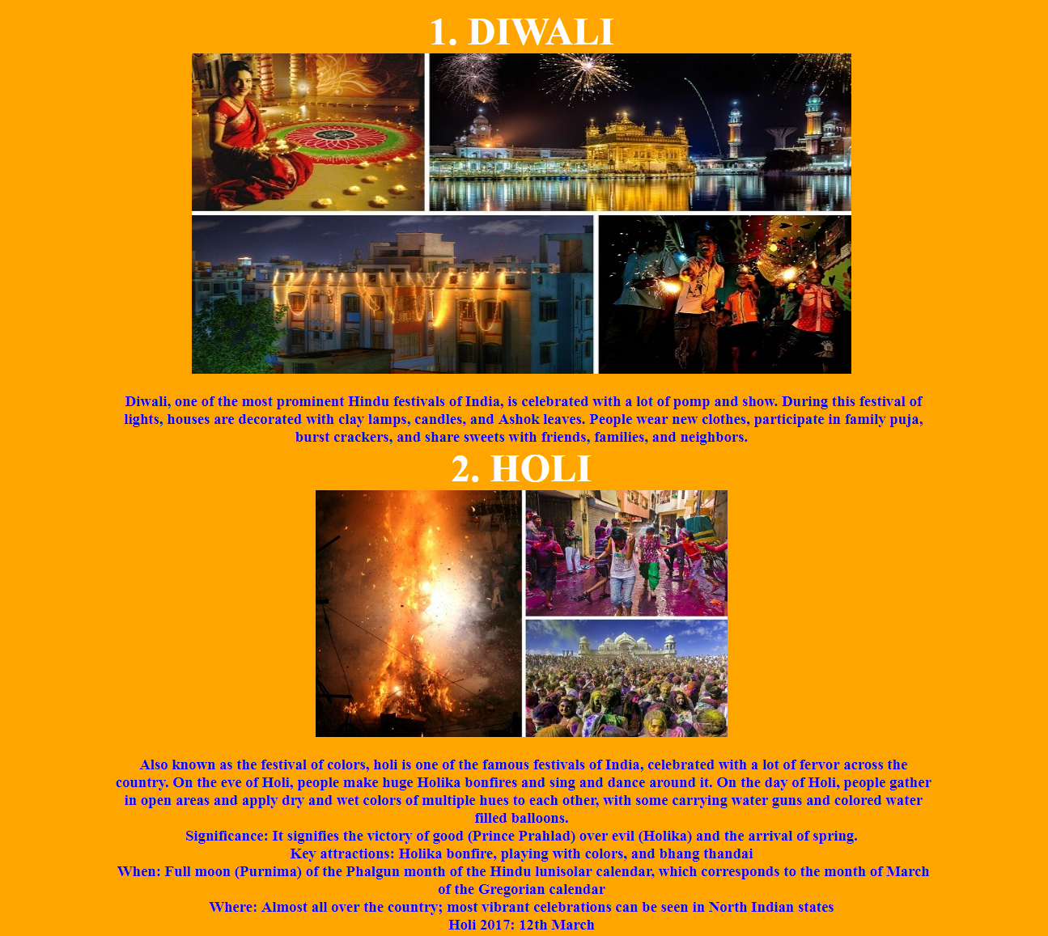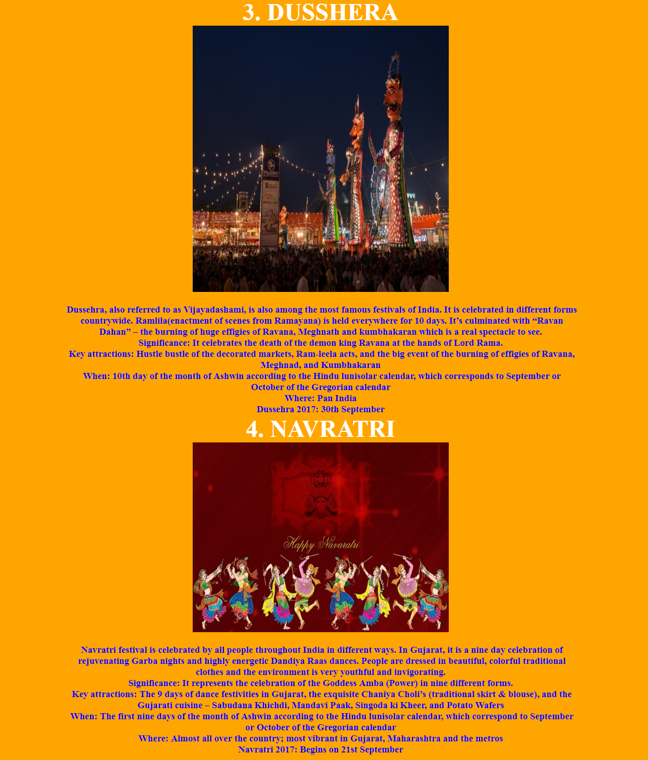

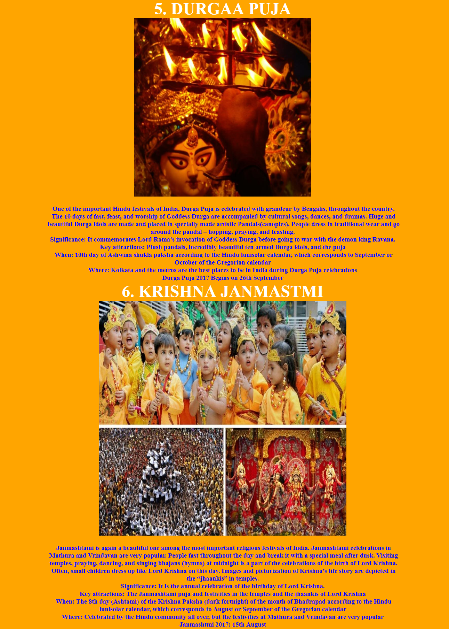

FESTIVAL PAGE

<html>

<head>

<title>festival</title>

</head>

<body bgcolor="orange">

<table border="1" bordercolor="#800000"><tr><th><a href=" HOME PAGE.html"><font color="800000" size="3">HOME</th></tr></table>

<center><img src="om.gif" width="62" height="70"></center>

<h1><center><font face="Comic Sans MS" color="blue" size="30"> indian festival</font></center></h1>

<center><img src="2.jpg" width="40%"height="60%"></center>

<center><table width="80%">

<tr>

<th >

<h3><p><b><font color=" blue">India is a land of festivals, where people from different religions coexist harmoniously. The wide variety of festivals celebrated in India is a true manifestation of its rich culture and traditions. There are many Indian festivals and celebrations, the most exciting of which are mentioned below. While the celebrations happen all over the year, October till January is the time when the country can be seen at its vibrant best.</font><p></b></h3>

<h2><u><i><font color="green">List of Indian Festivals: The widely celebrated religious festivals in the country</h2></font></i></u></center>

<font color="white" size="15">1. DIWALI</font>

<br>

<img src="diwali.jpg"width="80%"height="100%">

<br><h3><p><b><font color=" blue">Diwali, one of the most prominent Hindu festivals of India, is celebrated with a lot of pomp and show. During this festival of lights, houses are decorated with clay lamps, candles, and Ashok leaves. People wear new clothes, participate in family puja, burst crackers, and share sweets with friends, families, and neighbors.</font>

<br>

<font color="white" size="15">2. HOLI</font>

<br>

<img src="holi.jpg"width="50%"height="50%">

<br><h3><p><b><font color=" blue">Also known as the festival of colors, holi is one of the famous festivals of India, celebrated with a lot of fervor across the country. On the eve of Holi, people make huge Holika bonfires and sing and dance around it. On the day of Holi, people gather in open areas and apply dry and wet colors of multiple hues to each other, with some carrying water guns and colored water filled balloons.

<BR>

Significance: It signifies the victory of good (Prince Prahlad) over evil (Holika) and the arrival of spring.

<BR>

Key attractions: Holika bonfire, playing with colors, and bhang thandai

<BR>

When: Full moon (Purnima) of the Phalgun month of the Hindu lunisolar calendar, which corresponds to the month of March of the Gregorian calendar

<BR>

Where: Almost all over the country; most vibrant celebrations can be seen in North Indian states

<BR>

Holi 2017: 12th March</font>

<br>

<font color="white" size="15">3. DUSSHERA</font>

<br>

<img src="dus.jpg"width="50%"height="50%">

<br><h3><p><b><font color=" blue">Dussehra, also referred to as Vijayadashami, is also among the most famous festivals of India. It is celebrated in different forms countrywide. Ramlila(enactment of scenes from Ramayana) is held everywhere for 10 days. It’s culminated with “Ravan Dahan” – the burning of huge effigies of Ravana, Meghnath and kumbhakaran which is a real spectacle to see.

<BR>

Significance: It celebrates the death of the demon king Ravana at the hands of Lord Rama.

<BR>

Key attractions: Hustle bustle of the decorated markets, Ram-leela acts, and the big event of the burning of effigies of Ravana, Meghnad, and Kumbhakaran

<BR>

When: 10th day of the month of Ashwin according to the Hindu lunisolar calendar, which corresponds to September or October of the Gregorian calendar

<BR>

Where: Pan India

<BR>

Dussehra 2017: 30th September</font>

<br>

<font color="white" size="15">4. NAVRATRI</font>

<br>

<img src="Navratri.jpg"width="50%"height="20%">

<br><h3><p><b><font color=" blue">Navratri festival is celebrated by all people throughout India in different ways. In Gujarat, it is a nine day celebration of rejuvenating Garba nights and highly energetic Dandiya Raas dances. People are dressed in beautiful, colorful traditional clothes and the environment is very youthful and invigorating.

<BR>

Significance: It represents the celebration of the Goddess Amba (Power) in nine different forms.

<BR>

Key attractions: The 9 days of dance festivities in Gujarat, the exquisite Chaniya Choli’s (traditional skirt & blouse), and the Gujarati cuisine – Sabudana Khichdi, Mandavi Paak, Singoda ki Kheer, and Potato Wafers

<BR>

When: The first nine days of the month of Ashwin according to the Hindu lunisolar calendar, which correspond to September or October of the Gregorian calendar

<BR>

Where: Almost all over the country; most vibrant in Gujarat, Maharashtra and the metros

<BR>

Navratri 2017: Begins on 21st September</font>

<br>

<font color="white" size="15">5. DURGAA PUJA</font>

<br>

<img src="DURGA.jpg"width="50%"height="20%">

<br><h3><p><b><font color=" blue">One of the important Hindu festivals of India, Durga Puja is celebrated with grandeur by Bengalis, throughout the country. The 10 days of fast, feast, and worship of Goddess Durga are accompanied by cultural songs, dances, and dramas. Huge and beautiful Durga idols are made and placed in specially made artistic Pandals(canopies). People dress in traditional wear and go around the pandal – hopping, praying, and feasting.

<BR>

Significance: It commemorates Lord Rama’s invocation of Goddess Durga before going to war with the demon king Ravana.

<BR>

Key attractions: Plush pandals, incredibly beautiful ten armed Durga idols, and the puja

<BR>

When: 10th day of Ashwina shukla paksha according to the Hindu lunisolar calendar, which corresponds to September or October of the Gregorian calendar

<BR>

Where: Kolkata and the metros are the best places to be in India during Durga Puja celebrations

<BR>

Durga Puja 2017 Begins on 26th September</font>

<br>

<font color="white" size="15">6. KRISHNA JANMASTMI</font>

<br>

<img src="Janm.jpg"width="70%"height="20%">

<br><h3><p><b><font color=" blue">Janmashtami is again a beautiful one among the most important religious festivals of India. Janmashtami celebrations in Mathura and Vrindavan are very popular. People fast throughout the day and break it with a special meal after dusk. Visiting temples, praying, dancing, and singing bhajans (hymns) at midnight is a part of the celebrations of the birth of Lord Krishna. Often, small children dress up like Lord Krishna on this day. Images and picturization of Krishna’s life story are depicted in the “jhaankis” in temples.

<BR>

Significance: It is the annual celebration of the birthday of Lord Krishna.

<BR>

Key attractions: The Janmashtami puja and festivities in the temples and the jhaankis of Lord Krishna

<BR>

When: The 8th day (Ashtami) of the Krishna Paksha (dark fortnight) of the month of Bhadrapad according to the Hindu lunisolar calendar, which corresponds to August or September of the Gregorian calendar

<BR>

Where: Celebrated by the Hindu community all over, but the festivities at Mathura and Vrindavan are very popular

<BR>

Janmashtmi 2017: 15th August</font>

<br>

<font color="white" size="15">7. GANESH CHATURTHI</font>

<br>

<img src="Ganesh.jpg"width="80%"height="20%">

<br><h3><p><b><font color=" blue">Ganesh Chaturthi, another one of important Hindu religious festivals of India, is a 10-day affair of colorful festivities. Huge handcrafted Ganesh idols are installed in homes or outdoors, in public pandals. Pujas are performed in the morning and the evening. The last day is the day of Visarjan – immersion of an idol in a water body. Cultural activities of singing, dancing, and theater, and free medical and blood donation camps are held.

<BR>

Significance: It’s the birthday of Lord Ganesha, the elephant-headed God.

<BR>

Key attractions: The beautifully crafted life size idols of Ganesha, and the immersion ceremony

<BR>

When: The 4th day of the first fortnight (Shukla Chaturthi) in the month of Bhadrapada of the Hindu lunisolar calendar, which corresponds to August or September of the Gregorian calendar

<BR>

Where: Celebrated in the states of Maharashtra and Andhra Pradesh with fervor and gaiety

<BR>

Ganesh Chaturthi: 5th September</font>

<br>

<font color="white" size="15">8. GURU PURB</font>

<br>

<img src="gurupurab.jpg"width="100%"height="20%">

<br><h3><p><b><font color=" blue">On the most important Sikh festival of India, special assemblies on the lives and teachings of the gurus, and langars (community meals) are organized in the gurudwaras. Karah Prasad is distributed among all, and hymn chanting processions are held in the city. People light up their homes with lamps and candles and burst crackers to celebrate Gurpurab.

<BR>

Significance: It is the celebration of the anniversaries of the ten Sikh Gurus.

<BR>

Key attractions: The soulful Bhajan-Kirtan (hymns), Gurbani in the Gurdwaras, the Langar and the Karah Prasad

<BR>

When: The full moon day in the month of Kartik of the Hindu lunisolar calendar, which corresponds

to November of the Gregorian calendar

<BR>

Where: Celebrated by the Sikh community all over the world, especially in Punjab

<BR>

Gurupurab 2017: 5th January</font>

<br>

<font color="white" size="15">9. RAKSHA BANDHAN</font>

<br>

<img src="rakhi.jpg"width="60%"height="7%">

<br><h3><p><b><font color=" blue">One of the famous festivals of India, Rakhi is celebrated among Hindu. Signifying the brother-sister bonding, during Rakhi, the sister performs Aarti (prayer), applies tilak, and ties rakhi (a sacred thread) on the brother’s wrist wishing his well being. The brother, in return, vows to protect the sister. Another festival which has strong similarity to Rakhi is Bhaidooj which comes just after Diwali.

<BR>

Significance: It symbolizes the strong bonding of a brother and sister.

<BR>

Key attractions: The ritual of Rakhi and the brightly decked up markets showcasing a colourful variety of rakhis and sweets

<BR>

When: The full moon day of Shravana month of the Hindu lunisolar calendar, which corresponds to August of the Gregorian calendar

<BR>

Where: Particularly in North, Central and West India

<BR>

Rakshabandhan 2017: 7th August</font>

<br>

<font color="white" size="15">10. EID- UL- FITRA</font>

<br>

<img src="eid.JPG"width="60%"height="7%">

<br><h3><p><b><font color=" blue">Eid is one of the major festivals of India for the Muslim community. People dress up in fineries, attend a special community prayer in the morning, visit friends, and relatives and exchange sweets. Children are given idi(money or gift) by elders.

<BR>

Significance: It celebrates the conclusion of the holy month of fasting called Ramadan.

<BR>

Key attractions: The beautifully decked up markets and mosques, the morning Eid namaz at the mosques, and the sweet dishes.

<BR>

When: On the 1st day of the month of Shawwal of the lunar Hijri calendar, which corresponds to July of the Gregorian calendar

<BR>

Where: Celebrated by Muslims all over the country

<BR>

Eid Ul Fitr 2017: 26th June</font>

<br>

<font color="white" size="15">11. BIHU</font>

<br>

<img src="bihu-festival.jpg"width="60%"height="5%">

<br><h3><p><b><font color=" blue">Popular among the festivals of India celebrated in the North East, Bihu is the harvest festival of Assam. During the month-long celebrations, young men and women wear their traditional clothes and perform the Bihu dance in the village fields and courtyards. A community feast is held with a lot of fanfare.

<BR>

Significance: It’s the traditional new year celebration of Assamese.

<BR>

Key attractions: The Bihu dance and the local cuisine – coconut laddoo, til pitha, ghila pitha, and fish pitika

<BR>

When: 14th or 15th April

<BR>

Where: Celebrated by the Assamese diaspora around the world, especially in Assam

<BR>

Bihu 2017: Begins on 14th April</font>

<br>

<font color="white" size="15">12.HEMIS</font>

<br>

<img src="hemis-fesival.jpg"width="60%"height="5%">

<br><h3><p><b><font color=" blue">Hemis, the two-day religious festival from Ladakh, is one of the important festivals of India. It attracts a lot of locals and foreign tourists each year. The festivities include the Cham dance done by the priests to the tune of the traditional music of cymbals, drums, trumpets played by the monks. The dancing priests dress up in elaborate brocade outfits and masks.

<BR>

Significance: It’s the celebration of the birth anniversary of spiritual leader Padmasambhava, founder of Tibet Tantric Buddhism.

<BR>

Key attractions: The scenic Hemis monastery and the Cham dance

<BR>

When: 10th day (called Tse-Chu in the local language) of the Tibetan lunar month, which corresponds to June or July of the Gregorian calendar

<BR>

Where: Ladakh, Jammu & Kashmir

<BR>

Hemis 2017: Begins on 23rd June</font>

<br>

<font color="white" size="15">13. ONAM</font>

<br>

<img src="onam.jpg"width="60%"height="5%">

<br><h3><p><b><font color=" blue">Onam is among the important festivals of India, wherein people wear traditional wear, adorn houses with Pookalam (floral designs), and prepare Onasadya(elaborate meal of 11/13 dishes). Events such as Vallamkali(snake boat race), Kaikottikali(clap dance), Kathakali dance, and Pulikali procession(artists dressed and painted like tigers and hunters) are held.

<BR>

Significance: It celebrates the homecoming of the legendary king Mahabali.

<BR>

Key attractions: The spectacular Snake Boat Race, the enigmatic Kaikottikali dance, and the Elephant procession

<BR>

When: In the month of Chingam of the Malayalam calendar, which corresponds to August or September of the Gregorian calendar

<BR>

Where: Celebrated by people of all communities in the state of Kerala.

<BR>

Onam 2017: Begins on 25th August

</font>

<br>

<font color="white" size="15">14. PONGAL</font>

<br>

<img src="pongal.jpg"width="60%"height="4%">

<br><h3><p><b><font color=" blue">The four-day long harvest festival of South India is one of the most famous festivals of India. People prepare Pongal dish and wear their traditional attire. Celebrities include bonfires, dance, cattle races, sweets, and savories. The houses look resplendent with Kolam designs (traditional floral designs made with rice, colored powders, and flower petals)

<BR>

Significance: It’s a festival of thanksgiving to nature representing the first harvest of the year.

<BR>

Key attractions: The variety of Kolam designs and cattle races

<BR>

When: 14th or 15th January

<BR>

Where: Celebrated by Tamils all over India, primarily in Tamil Nadu

<BR>

Pongal 2017: Begins on 13th January</font>

<br>

<font color="white" size="15">15. Christmas</font>

<br>

<img src="christmas-tree-and-firplace.jpg"width="60%"height="4%">

<br><h3><p><b><font color=" blue">One of the most famous and awaited festival in the world, Christmas happens to be of sheer significance for elders and children alike. Everyone regardless of their religion wait for this day, children specifically for the surprise gifts from Santa. All the churches are lit up and decorated to celebrate the birth of Lord Jesus.

<BR>

Significance: Birthday of Lord Jesus

<BR>

Key attractions: Christmas tree decoration, prayers, birth of Lord Jesus and Santa Claus

<BR>

When: 25th December

<BR>

Where: The festival is celebrated across India. The best places to celebrate Christmas in India are Goa, Pondicherry, and Kerala.

<BR>

Christmas 2017: 25th December</font>

GALLERY PAGE

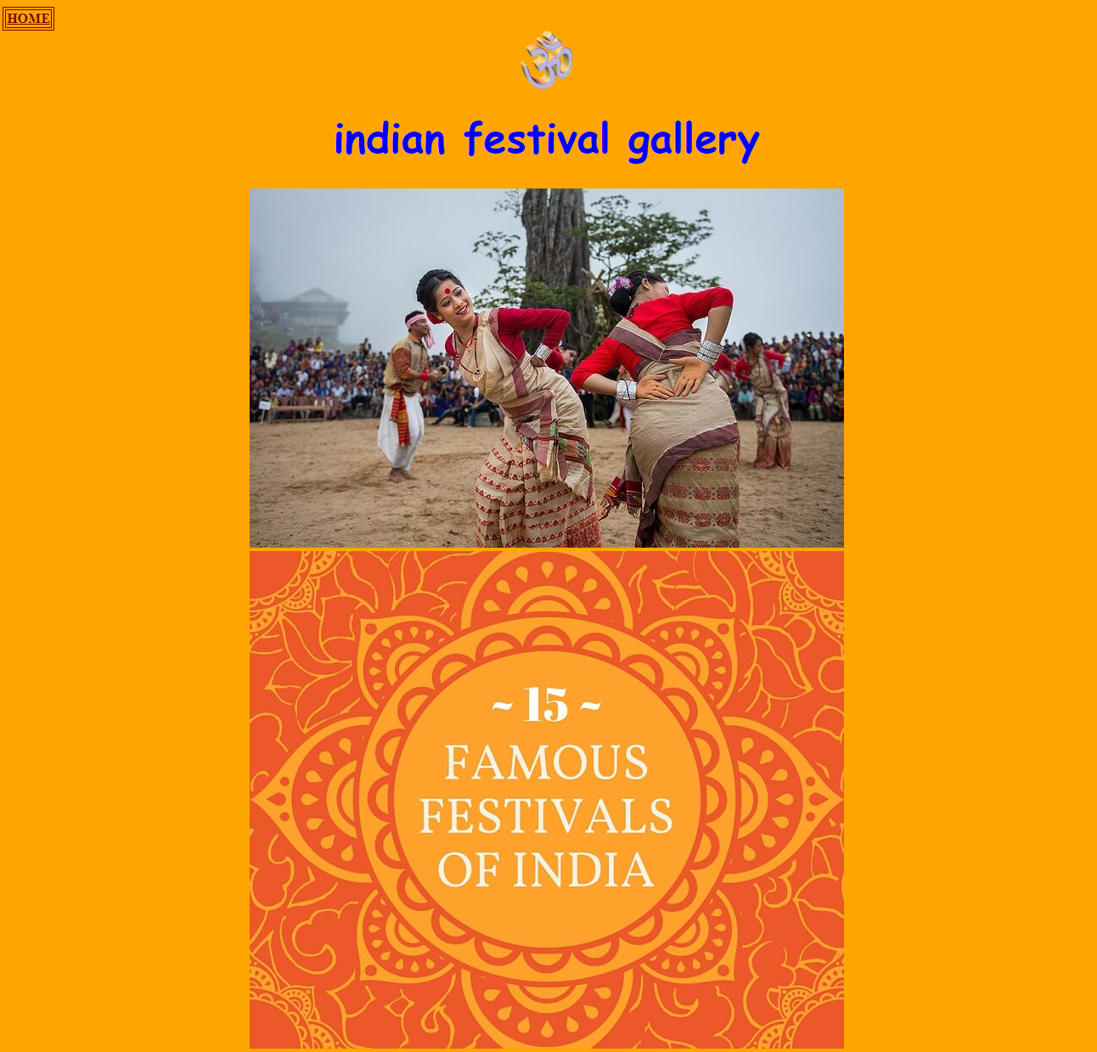

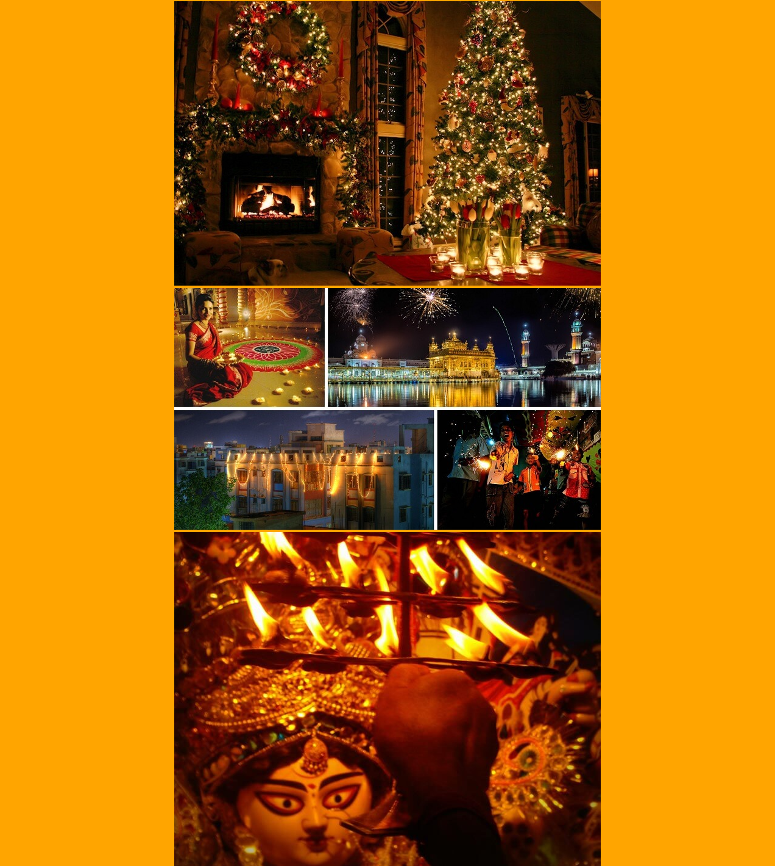

GALLERY

<html>

<head>

<title>gallery</title>

</head>

<body bgcolor="orange">

<table border="1" bordercolor="#800000"><tr><th><a href=" HOME PAGE.html"><font color="800000" size="3">HOME</th></tr></table>

<center><img src="om.gif" width="62" height="70"></center>

<h1><center><font face="Comic Sans MS" color="blue" size="30"> indian festival gallery</font></center></h1>

<center><table width="80%">

<tr>

<th >

<center><table width="80%"></th>

<tr><th ><img src="bihu-festival.jpg"></th></tr>

<tr><th ><img src="2.jpg"></th>

</tr>

<tr><th ><img src="christmas-tree-and-firplace.jpg"></th></tr>

<tr><th ><img src="diwali.jpg"></th></tr>

<tr><th ><img src="DURGA.jpg"></th>

</tr>

<tr>

<th ><img src="hemis-fesival.jpg"></th></tr>

<tr><th ><img src="holi.jpg"></th></tr>

<tr><th ><img src="janm.jpg"></th>

</tr>

<tr>

<th ><img src="onam.jpg"></th></tr>

<tr><th ><img src="dus.jpg"></th></tr>

<tr><th ><img src="Ganesh.jpg"></th>

</tr>

<tr>

<th ><img src="eid.jpg"></th></tr>

<tr><th ><img src="gurupurab.jpg"></th></tr>

<tr><th ><img src=".pongaljpg"></th>

</tr>

<tr>

<th ><img src="rakhi.jpg"></th></tr>

<tr><th ><img src="Kolkata-Durga-Puja-2015.jpg"></th>

PAGE DEVELOPED BY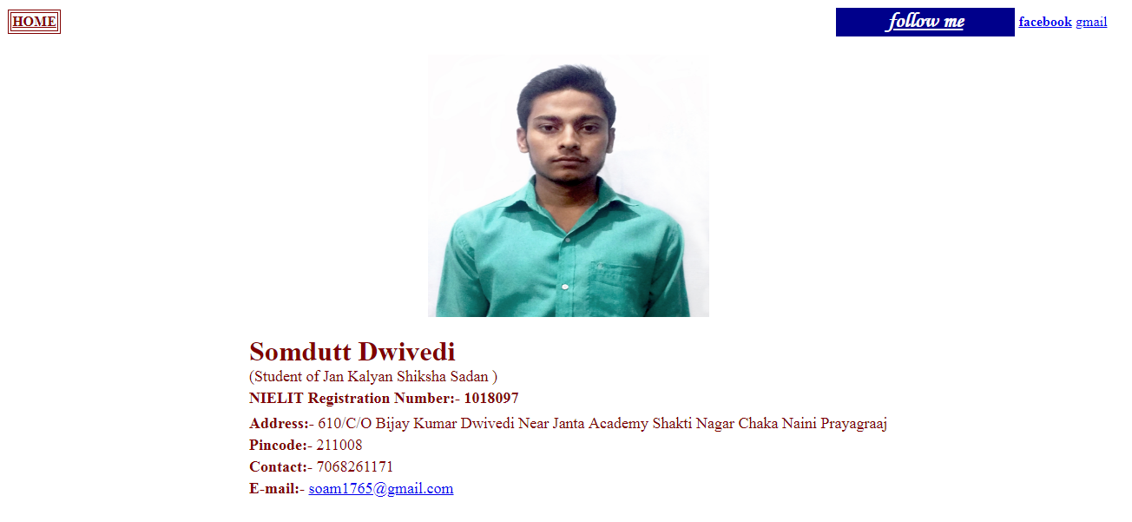

THE PAGE DEVELOPED BY

<html><head><title>SOMDUTT DWIVEDI</title></head>

<body background="73.jpg"><table width="100%" border="0"><tr><td width="10%"><table border="1" bordercolor="#800000"><tr><th><a href=" HOME PAGE.html"><font color="800000" size="3">HOME</th></tr></table><td><table bgcolor="darkblue" width="20%"align="Right"><tr><td><font size="5" face="monotype corsiva" color="white"><b><u><center>follow me</center></td></tr></table><th width="5%"><a href="https://www.facebook.com" title="Facebook (a secure search engine)">facebook</td><td width="5%"><a href="https://accounts.google.com/ServiceLogin?continue=https%3A%2F%2Fmail.google.com%2Fmail%2F%3Ftab%3Dwm&ltmpl=default&service=mail&scc=1&passive=1209600&sacu=1&ignoreShadow=0&acui=1#Email=ashishmishra262@gmail.com" title="Google plus">gmail</a></td></tr></table>

<br><center><img src="SOM.jpg" height="50%"width="25%" title="Somdutt Dwivedi" height="300" width="200"><br><br><center><table><tr><td><font size="6" color="#800000"><b>Somdutt Dwivedi &nbsp<font size="3"></b><br><font size="4"> (Student of Jan Kalyan Shiksha Sadan )</td></tr><tr><td><font size="4" color="#800000"><b>NIELIT Registration Number:- 1018097</td></tr><tr><td><font size="4" color="#800000"><b></td></tr><tr><td><font size="4" color="#800000"><b>Address:- </b>610/C/O Bijay Kumar Dwivedi Near Janta Academy Shakti Nagar Chaka Naini Prayagraaj </td></tr><tr><td><font size="4" color="#800000"><b>Pincode:- </b>211008</td></tr><tr><td><font size="4" color="#800000"><b>Contact:- </b>7068261171</td></tr><tr><td><font size="4" color="#800000"><b>E-mail:- </b><a href="https://accounts.google.com/ServiceLogin?continue=https%3A%2F%2Fmail.google.com%2Fmail%2F%3Ftab%3Dwm&ltmpl=default&service=mail&scc=1&passive=1209600&sacu=1&ignoreShadow=0&acui=1#Email=soam1765@gmail.com" title="Google plus">[soam1765@gmail.com</a></td></tr></table></html](mailto:soam1765@gmail.com%3c/a%3e%3c/td%3e%3c/tr%3e%3c/table%3e%3c/html)>

JANUARY

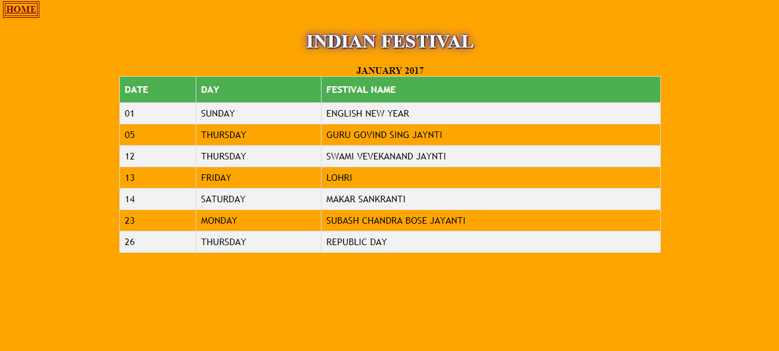

January

<html>

<head>

<title>indian calander</title>

</head>

<body bgcolor="orange">

<table border="1" bordercolor="#800000"><tr><th><a href=" HOME PAGE.html"><font color="800000" size="3">HOME</th></tr></table>

<center><html>

<head>

<style>

h1 {

color: white;

text-shadow: 1px 1px 2px black, 0 0 25px blue, 0 0 5px darkblue;

}

</style>

</head>

<body>

<h1>INDIAN FESTIVAL</h1>

<b><center><html>

<head>

<style>

#customers {

font-family: "Trebuchet MS", Arial, Helvetica, sans-serif;

border-collapse: collapse;

width: 70%;

}

#customers td, #customers th {

border: 1px solid #ddd;

padding: 8px;

}

#customers tr:nth-child(even){background-color: #f2f2f2;}

#customers tr:hover {background-color: #ddd;}

#customers th {

padding-top: 12px;

padding-bottom: 12px;

text-align: left;

background-color: #4CAF50;

color: white;

}

</style>

</head>

<body>

<center>JANUARY 2017</CENTER>

<CENTER><table id="customers" WIDTH="50%">

<tr>

<th>DATE</th>

<th>DAY</th>

<th>FESTIVAL NAME</th>

</tr>

<tr>

<td>01</td>

<td>SUNDAY</td>

<td>ENGLISH NEW YEAR</td>

</tr>

<tr>

<td>05</td>

<td>THURSDAY</td>

<td>GURU GOVIND SING JAYNTI</td>

</tr>

<tr>

<td>12</td>

<td>THURSDAY</td>

<td>SWAMI VEVEKANAND JAYNTI</td>

</tr>

<tr>

<td>13</td>

<td>FRIDAY</td>

<td>LOHRI</td>

</tr>

<tr>

<td>14</td>

<td>SATURDAY</td>

<td>MAKAR SANKRANTI</td>

</tr>

<tr>

<td>23</td>

<td>MONDAY</td>

<td>SUBASH CHANDRA BOSE JAYANTI</td>

</tr>

<tr>

<td>26</td>

<td>THURSDAY</td>

<td>REPUBLIC DAY</td>

</tr>

</table>

FEBURARY

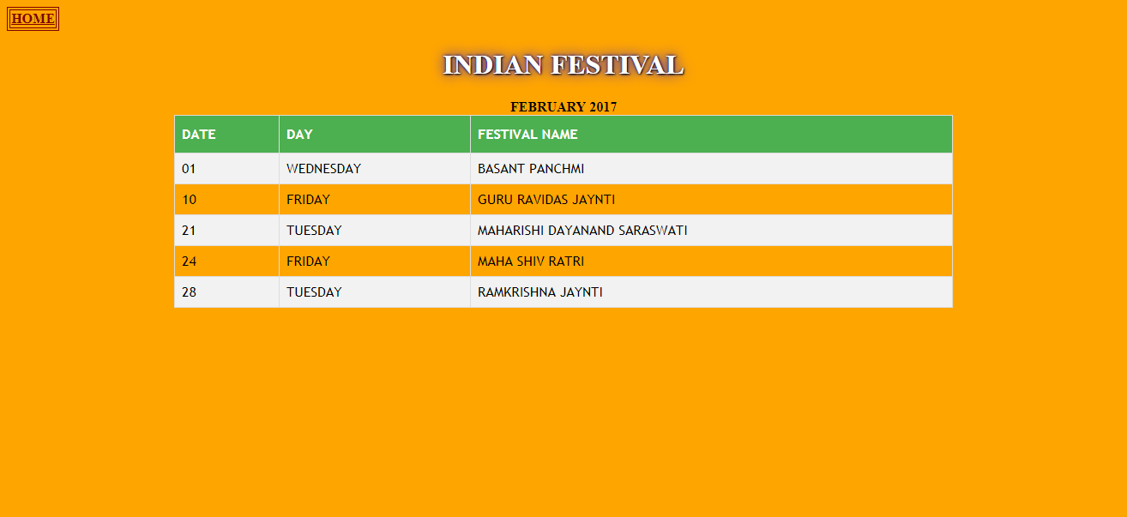

FEBURARY

<html>

<head>

<title>indian calander</title>

</head>

<body bgcolor="orange">

<table border="1" bordercolor="#800000"><tr><th><a href=" HOME PAGE.html"><font color="800000" size="3">HOME</th></tr></table>

<center><html>

<head>

<style>

h1 {

color: white;

text-shadow: 1px 1px 2px black, 0 0 25px blue, 0 0 5px darkblue;

}

</style>

</head>

<body>

<h1>INDIAN FESTIVAL</h1>

<b><center>

<html>

<head>

<style>

#customers {

font-family: "Trebuchet MS", Arial, Helvetica, sans-serif;

border-collapse: collapse;

width: 70%;

}

#customers td, #customers th {

border: 1px solid #ddd;

padding: 8px;

}

#customers tr:nth-child(even){background-color: #f2f2f2;}

#customers tr:hover {background-color: #ddd;}

#customers th {

padding-top: 12px;

padding-bottom: 12px;

text-align: left;

background-color: #4CAF50;

color: white;

}

</style>

</head>

<body>

<center>FEBRUARY 2017</CENTER>

<CENTER><table id="customers" WIDTH="50%"><tr>

<th>DATE</th>

<th>DAY</th>

<th>FESTIVAL NAME</th>

</tr>

<tr>

<td>01</td>

<td>WEDNESDAY</td>

<td>BASANT PANCHMI</td>

</tr><tr>

<td>10</td>

<td>FRIDAY</td>

<td>GURU RAVIDAS JAYNTI</td>

</tr> <tr>

<td>21</td>

<td>TUESDAY</td>

<td>MAHARISHI DAYANAND SARASWATI</td>

</tr> <tr>

<td>24</td>

<td>FRIDAY</td>

<td>MAHA SHIV RATRI</td>

</tr><tr>

<td>28</td>

<td>TUESDAY</td>

<td>RAMKRISHNA JAYNTI</td>

</tr>

</table>

MARCH 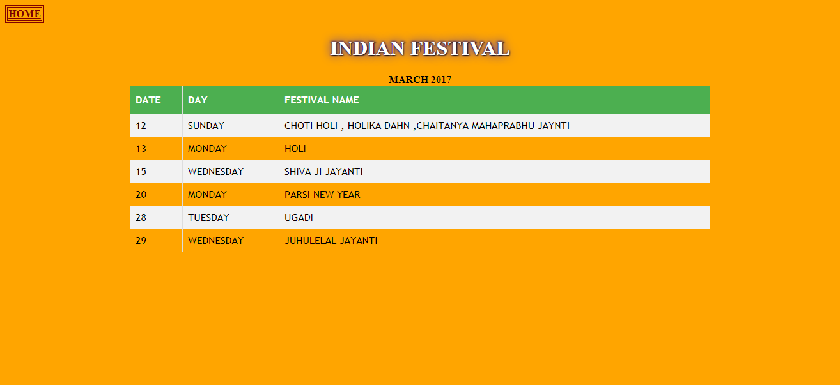

MARCH

<html>

<head>

<title>indian calander</title>

</head>

<body bgcolor="orange">

<table border="1" bordercolor="#800000"><tr><th><a href=" HOME PAGE.html"><font color="800000" size="3">HOME</th></tr></table>

<center><html>

<head>

<style>

h1 {

color: white;

text-shadow: 1px 1px 2px black, 0 0 25px blue, 0 0 5px darkblue;

}

</style>

</head>

<body>

<h1>INDIAN FESTIVAL</h1>

<b><center>

<html>

<head>

<style>

#customers {

font-family: "Trebuchet MS", Arial, Helvetica, sans-serif;

border-collapse: collapse;

width: 70%;

}

#customers td, #customers th {

border: 1px solid #ddd;

padding: 8px;

}

#customers tr:nth-child(even){background-color: #f2f2f2;}

#customers tr:hover {background-color: #ddd;}

#customers th {

padding-top: 12px;

padding-bottom: 12px;

text-align: left;

background-color: #4CAF50;

color: white;

}

</style>

</head>

<body>

<center>MARCH 2017</CENTER>

<CENTER><table id="customers" WIDTH="50%">

<tr>

<th>DATE</th>

<th>DAY</th>

<th>FESTIVAL NAME</th>

</tr>

<tr>

<td>12</td>

<td>SUNDAY</td>

<td>CHOTI HOLI , HOLIKA DAHN ,CHAITANYA MAHAPRABHU JAYNTI</td>

</tr>

<tr>

<td>13</td>

<td>MONDAY</td>

<td>HOLI</td>

</tr>

<tr>

<td>15</td>

<td>WEDNESDAY</td>

<td>SHIVA JI JAYANTI</td>

</tr>

<tr>

<td>20</td>

<td>MONDAY</td>

<td>PARSI NEW YEAR</td>

</tr>

<tr>

<td>28</td>

<td>TUESDAY</td>

<td>UGADI</td>

</tr>

<tr>

<td>29</td>

<td>WEDNESDAY</td>

<td>JUHULELAL JAYANTI</td>

</tr>

</table>

APRIL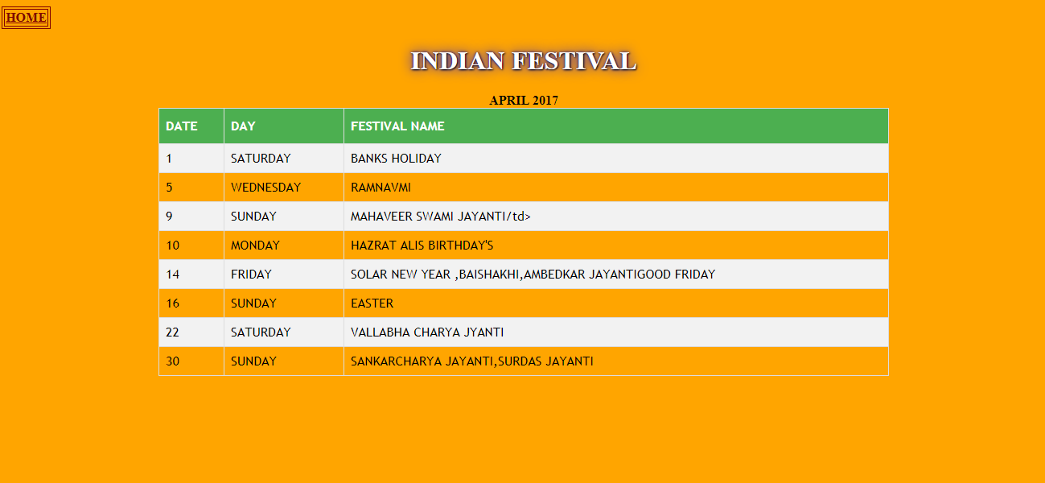

APRIL

<html>

<head>

<title>indian calander</title>

</head>

<body bgcolor="orange">

<table border="1" bordercolor="#800000"><tr><th><a href=" HOME PAGE.html"><font color="800000" size="3">HOME</th></tr></table>

<center><html>

<head>

<style>

h1 {

color: white;

text-shadow: 1px 1px 2px black, 0 0 25px blue, 0 0 5px darkblue;

}

</style>

</head>

<body>

<h1>INDIAN FESTIVAL</h1>

<b><center>

<html>

<head>

<style>

#customers {

font-family: "Trebuchet MS", Arial, Helvetica, sans-serif;

border-collapse: collapse;

width: 70%;

}

#customers td, #customers th {

border: 1px solid #ddd;

padding: 8px;

}

#customers tr:nth-child(even){background-color: #f2f2f2;}

#customers tr:hover {background-color: #ddd;}

#customers th {

padding-top: 12px;

padding-bottom: 12px;

text-align: left;

background-color: #4CAF50;

color: white;

}

</style>

</head>

<body>

<center> APRIL 2017</CENTER>

<CENTER><table id="customers" WIDTH="50%">

<tr>

<th>DATE</th>

<th>DAY</th>

<th>FESTIVAL NAME</th>

</tr>

<tr>

<td>1</td>

<td>SATURDAY</td>

<td>BANKS HOLIDAY </td>

</tr>

<tr>

<td>5</td>

<td>WEDNESDAY</td>

<td> RAMNAVMI</td>

</tr>

<tr>

<td>9</td>

<td>SUNDAY</td>

<td> MAHAVEER SWAMI JAYANTI/td>

</tr>

<tr><td>10</td>

<td>MONDAY</td>

<td>HAZRAT ALIS BIRTHDAY'S</td>

</tr> <tr>

<td>14</td>

<td>FRIDAY</td>

<td>SOLAR NEW YEAR ,BAISHAKHI,AMBEDKAR JAYANTIGOOD FRIDAY</td>

</tr>

<tr>

<td>16</td>

<td>SUNDAY</td>

<td>EASTER</td>

</tr>

<tr>

<td>22</td>

<td>SATURDAY</td>

<td>VALLABHA CHARYA JYANTI </TD>

</tr><tr><td>30</td>

<td>SUNDAY</td>

<td>SANKARCHARYA JAYANTI,SURDAS JAYANTI</td></tr>

</table>

MAY 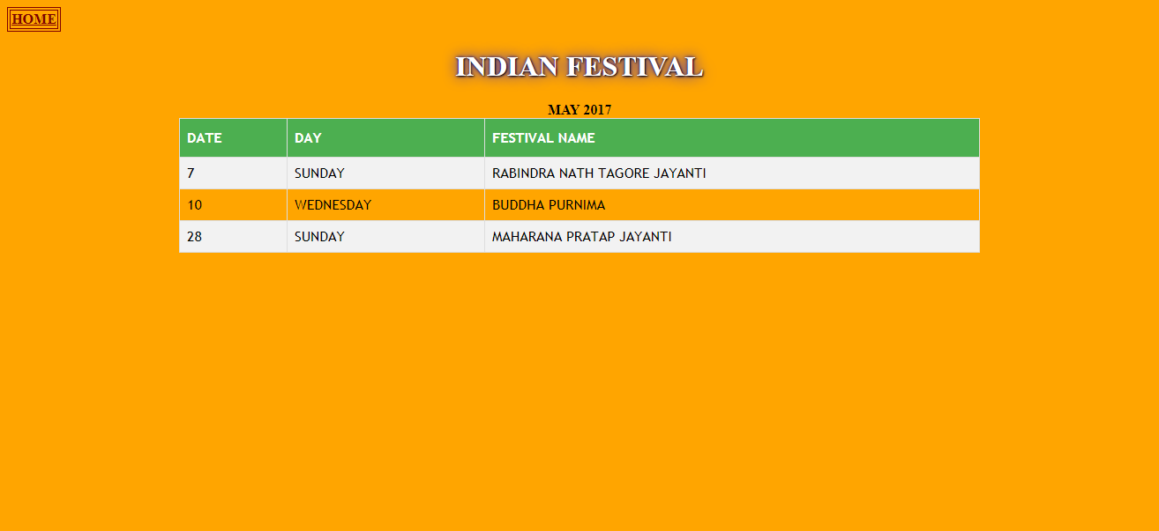

MAY

<html>

<head>

<title>indian calander</title>

</head>

<body bgcolor="orange">

<table border="1" bordercolor="#800000"><tr><th><a href=" HOME PAGE.html"><font color="800000" size="3">HOME</th></tr></table>

<center><html>

<head>

<style>

h1 {

color: white;

text-shadow: 1px 1px 2px black, 0 0 25px blue, 0 0 5px darkblue;

}

</style>

</head>

<body>

<h1>INDIAN FESTIVAL</h1>

<b><center>

<html>

<head>

<style>

#customers {

font-family: "Trebuchet MS", Arial, Helvetica, sans-serif;

border-collapse: collapse;

width: 70%;

}

#customers td, #customers th {

border: 1px solid #ddd;

padding: 8px;

}

#customers tr:nth-child(even){background-color: #f2f2f2;}

#customers tr:hover {background-color: #ddd;}

#customers th {

padding-top: 12px;

padding-bottom: 12px;

text-align: left;

background-color: #4CAF50;

color: white;

}

</style>

</head>

<body>

<center>MAY 2017</CENTER>

<CENTER><table id="customers" WIDTH="50%">

<tr>

<th>DATE</th>

<th>DAY</th>

<th>FESTIVAL NAME</th>

</tr><tr><td>7</td>

<td>SUNDAY</td>

<td>RABINDRA NATH TAGORE JAYANTI</td>

</tr> <tr>

<td>10</td>

<td>WEDNESDAY</td>

<td> BUDDHA PURNIMA</td>

</tr> <tr>

<td>28</td>

<td>SUNDAY</td>

<td> MAHARANA PRATAP JAYANTI</td>

</tr>

</table>

JUNE

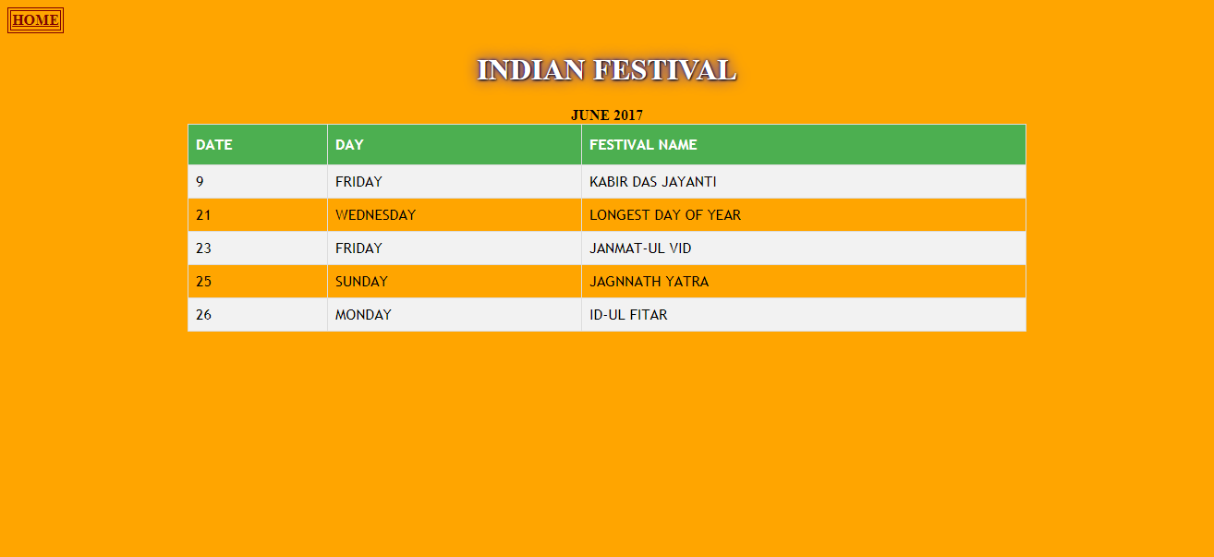

JUNE

<html>

<head>

<title>indian calander</title>

</head>

<body bgcolor="orange">

<table border="1" bordercolor="#800000"><tr><th><a href=" HOME PAGE.html"><font color="800000" size="3">HOME</th></tr></table>

<center><html>

<head>

<style>

h1 {

color: white;

text-shadow: 1px 1px 2px black, 0 0 25px blue, 0 0 5px darkblue;

}

</style>

</head>

<body>

<h1>INDIAN FESTIVAL</h1>

<b><center>

<html>

<head>

<style>

#customers {

font-family: "Trebuchet MS", Arial, Helvetica, sans-serif;

border-collapse: collapse;

width: 70%;

}

#customers td, #customers th {

border: 1px solid #ddd;

padding: 8px;

}

#customers tr:nth-child(even){background-color: #f2f2f2;}

#customers tr:hover {background-color: #ddd;}

#customers th {

padding-top: 12px;

padding-bottom: 12px;

text-align: left;

background-color: #4CAF50;

color: white;

}

</style>

</head>

<body>

<center>JUNE 2017</CENTER>

<CENTER><table id="customers" WIDTH="50%">

<tr>

<th>DATE</th>

<th>DAY</th>

<th>FESTIVAL NAME</th>

</tr>

<tr>

<td>9</td>

<td>FRIDAY</td>

<td>KABIR DAS JAYANTI</td>

</tr>

<tr>

<td>21</td>

<td>WEDNESDAY</td>

<td> LONGEST DAY OF YEAR</td>

</tr>

<tr>

<td>23</td>

<td>FRIDAY</td>

<td>JANMAT-UL VID</td></tr>

<tr>

<td>25</td>

<td>SUNDAY</td>

<td> JAGNNATH YATRA</td>

</tr>

<tr>

<td>26</td>

<td>MONDAY</td>

<td> ID-UL FITAR</td> </table>

JULY

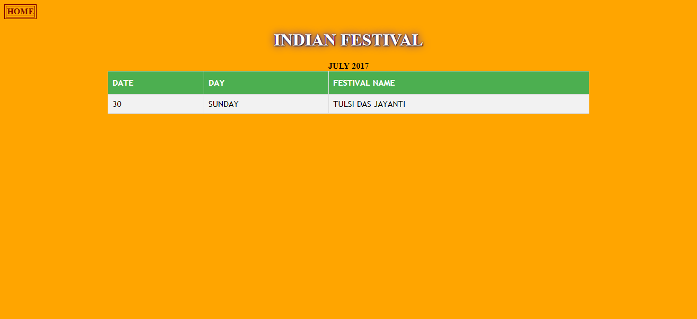

JULY

<html>

<head>

<title>indian calander</title>

</head>

<body bgcolor="orange">

<table border="1" bordercolor="#800000"><tr><th><a href=" HOME PAGE.html"><font color="800000" size="3">HOME</th></tr></table>

<center><html>

<head>

<style>

h1 {

color: white;

text-shadow: 1px 1px 2px black, 0 0 25px blue, 0 0 5px darkblue;

}

</style>

</head>

<body>

<h1>INDIAN FESTIVAL</h1>

<b><center>

<html>

<head>

<style>

#customers {

font-family: "Trebuchet MS", Arial, Helvetica, sans-serif;

border-collapse: collapse;

width: 70%;

}

#customers td, #customers th {

border: 1px solid #ddd;

padding: 8px;

}

#customers tr:nth-child(even){background-color: #f2f2f2;}

#customers tr:hover {background-color: #ddd;}

#customers th {

padding-top: 12px;

padding-bottom: 12px;

text-align: left;

background-color: #4CAF50;

color: white;

}

</style>

</head>

<body>

<center>JULY 2017</CENTER>

<CENTER><table id="customers" WIDTH="50%">

<tr>

<th>DATE</th>

<th>DAY</th>

<th>FESTIVAL NAME</th>

</tr>

<tr>

<td>30</td>

<td>SUNDAY</td>

<td>TULSI DAS JAYANTI</td>

</tr></table>

AUGUST

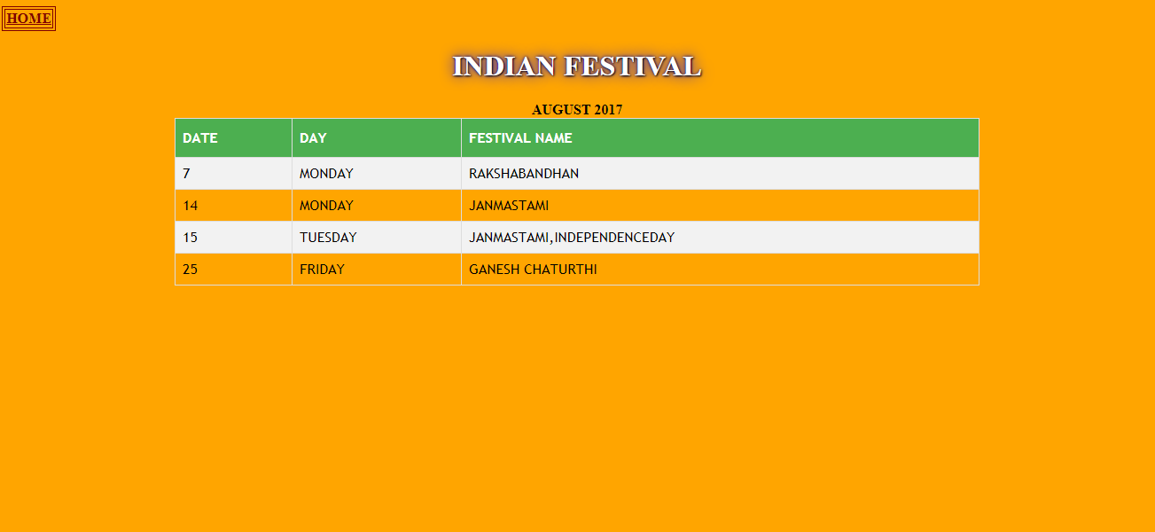

AUGUST

<html>

<head>

<title>indian calander</title>

</head>

<body bgcolor="orange">

<table border="1" bordercolor="#800000"><tr><th><a href=" HOME PAGE.html"><font color="800000" size="3">HOME</th></tr></table>

<center><html>

<head>

<style>

h1 {

color: white;

text-shadow: 1px 1px 2px black, 0 0 25px blue, 0 0 5px darkblue;

}

</style>

</head>

<body>

<h1>INDIAN FESTIVAL</h1>

<b><center>

<html>

<head>

<style>

#customers {

font-family: "Trebuchet MS", Arial, Helvetica, sans-serif;

border-collapse: collapse;

width: 70%;

}

#customers td, #customers th {

border: 1px solid #ddd;

padding: 8px;

}

#customers tr:nth-child(even){background-color: #f2f2f2;}

#customers tr:hover {background-color: #ddd;}

#customers th {

padding-top: 12px;

padding-bottom: 12px;

text-align: left;

background-color: #4CAF50;

color: white;

}

</style>

</head>

<body>

<center>AUGUST 2017</CENTER>

<CENTER><table id="customers" WIDTH="50%">

<tr>

<th>DATE</th>

<th>DAY</th>

<th>FESTIVAL NAME</th>

</tr>

<tr>

<td>7</td>

<td>MONDAY</td>

<td>RAKSHABANDHAN</td>

</tr>

<tr>

<td>14</td>

<td>MONDAY</td>

<td> JANMASTAMI</td>

</tr>

<tr>

<td>15</td>

<td>TUESDAY</td>

<td> JANMASTAMI,INDEPENDENCEDAY</td>

</tr>

<tr>

<td>25</td>

<td>FRIDAY</td>

<td> GANESH CHATURTHI</td>

</tr>

</table>

SEPTEMBER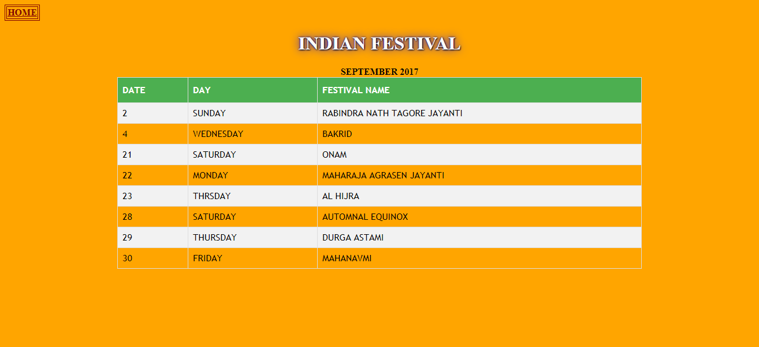

SEPTEMBER

<html>

<head>

<title>indian calander</title>

</head>

<body bgcolor="orange">

<table border="1" bordercolor="#800000"><tr><th><a href=" HOME PAGE.html"><font color="800000" size="3">HOME</th></tr></table>

<center><html>

<head>

<style>

h1 {

color: white;

text-shadow: 1px 1px 2px black, 0 0 25px blue, 0 0 5px darkblue;

}

</style>

</head><body>

<h1>INDIAN FESTIVAL</h1>

<b><center><html><head>

<style>

#customers {

font-family: "Trebuchet MS", Arial, Helvetica, sans-serif;

border-collapse: collapse;

width: 70%;

}

#customers td, #customers th {

border: 1px solid #ddd;

padding: 8px;

}

#customers tr:nth-child(even){background-color: #f2f2f2;}

#customers tr:hover {background-color: #ddd;}

#customers th {

padding-top: 12px;

padding-bottom: 12px;

text-align: left;

background-color: #4CAF50;

color: white;

}

</style>

</head>

<body>

<center>SEPTEMBER 2017</CENTER>

<CENTER><table id="customers" WIDTH="50%">

<tr>

<th>DATE</th>

<th>DAY</th>

<th>FESTIVAL NAME</th>

</tr>

<tr>

<td>2</td>

<td>SUNDAY</td>

<td>RABINDRA NATH TAGORE JAYANTI</td>

</tr>

<tr>

<td>4</td>

<td>WEDNESDAY</td>

<td> BAKRID</td>

</tr>

<tr>

<td>21</td>

<td>SATURDAY</td>

<td> ONAM</td>

</tr>

<tr>

<td>22</td>

<td>MONDAY</td>

<td> MAHARAJA AGRASEN JAYANTI</td>

</tr>

<tr>

<td>23</td>

<td>THRSDAY</td>

<td> AL HIJRA</td>

</tr>

<tr>

<td>28</td>

<td>SATURDAY</td>

<td> AUTOMNAL EQUINOX</td>

</tr>

<tr>

<td>29</td>

<td>THURSDAY</td>

<td> DURGA ASTAMI</td>

</tr> <tr>

<td>30</td>

<td>FRIDAY</td>

<td> MAHANAVMI</td>

</tr> </table>

OCTOBER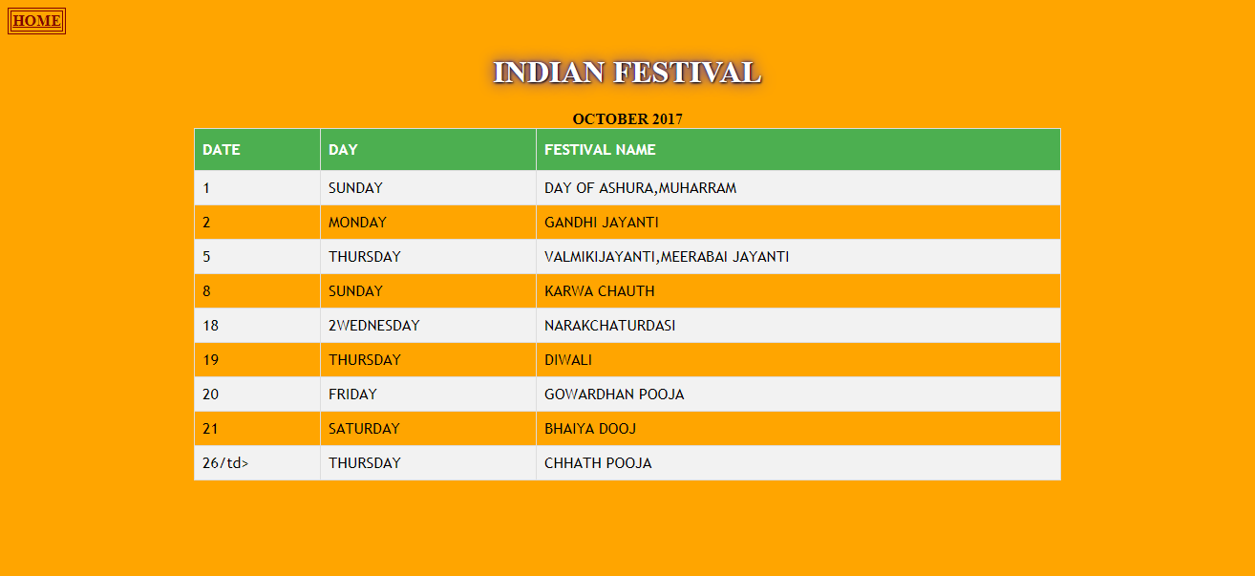

OCTOBER

<html>

<head>

<title>indian calander</title>

</head>

<body bgcolor="orange">

<table border="1" bordercolor="#800000"><tr><th><a href=" HOME PAGE.html"><font color="800000" size="3">HOME</th></tr></table>

<center><html>

<head>

<style>

h1 {

color: white;

text-shadow: 1px 1px 2px black, 0 0 25px blue, 0 0 5px darkblue;

}

</style>

</head>

<body>

<h1>INDIAN FESTIVAL</h1>

<b><center>

<html>

<head>

<style>

#customers {

font-family: "Trebuchet MS", Arial, Helvetica, sans-serif;

border-collapse: collapse;

width: 70%;

}

#customers td, #customers th {

border: 1px solid #ddd;

padding: 8px;

}

#customers tr:nth-child(even){background-color: #f2f2f2;}

#customers tr:hover {background-color: #ddd;}

#customers th {

padding-top: 12px;

padding-bottom: 12px;

text-align: left;

background-color: #4CAF50;

color: white;

}

</style>

</head>

<body>

<center>OCTOBER 2017</CENTER>

<CENTER><table id="customers" WIDTH="50%">

<tr>

<th>DATE</th>

<th>DAY</th>

<th>FESTIVAL NAME</th>

</tr><tr>

<td>1</td>

<td>SUNDAY</td>

<td>DAY OF ASHURA,MUHARRAM</td>

</tr>

<tr>

<td>2</td>

<td>MONDAY</td>

<td> GANDHI JAYANTI</td> </tr><tr>

<td>5</td>

<td>THURSDAY</td>

<td> VALMIKIJAYANTI,MEERABAI JAYANTI</td>

</tr><tr>

<td>8</td>

<td>SUNDAY</td>

<td> KARWA CHAUTH</td>

</tr><tr><td>18</td>

<td>2WEDNESDAY</td>

<td>NARAKCHATURDASI</td></tr> <tr>

<td>19</td>

<td>THURSDAY</td>

<td> DIWALI</td>

</tr> <tr>

<td>20</td>

<td>FRIDAY</td>

<td> GOWARDHAN POOJA</td>

</tr> <tr> <td>21</td>

<td>SATURDAY</td>

<td> BHAIYA DOOJ</td>

</tr>

<tr>

<td>26/td>

<td>THURSDAY</td>

<td> CHHATH POOJA</td>

</tr>

</table>

NOVEMBER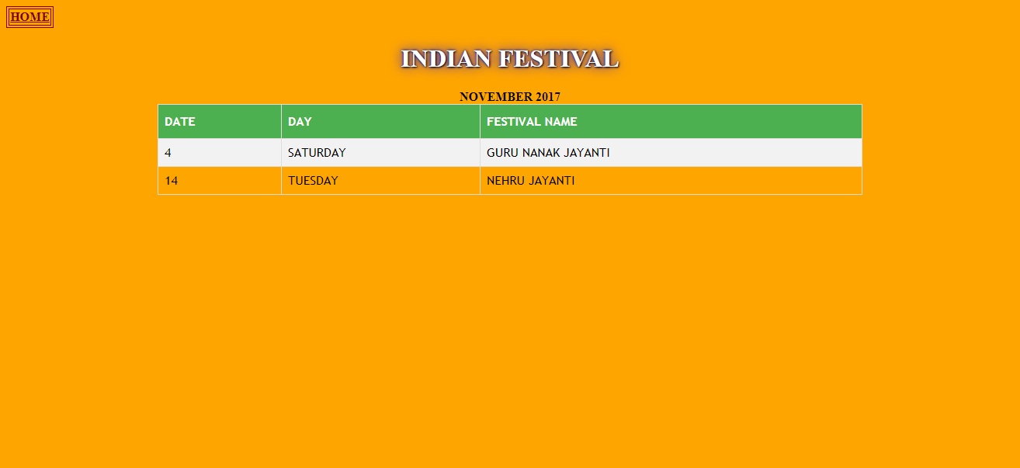

NOVEMBER

<html>

<head>

<title>indian calander</title>

</head>

<body bgcolor="orange">

<table border="1" bordercolor="#800000"><tr><th><a href=" HOME PAGE.html"><font color="800000" size="3">HOME</th></tr></table>

<center><html>

<head>

<style>

h1 {

color: white;

text-shadow: 1px 1px 2px black, 0 0 25px blue, 0 0 5px darkblue;

}

</style>

</head>

<body>

<h1>INDIAN FESTIVAL</h1>

<b><center>

<html>

<head>

<style>

#customers {

font-family: "Trebuchet MS", Arial, Helvetica, sans-serif;

border-collapse: collapse;

width: 70%;

}

#customers td, #customers th {

border: 1px solid #ddd;

padding: 8px;

}

#customers tr:nth-child(even){background-color: #f2f2f2;}

#customers tr:hover {background-color: #ddd;}

#customers th {

padding-top: 12px;

padding-bottom: 12px;

text-align: left;

background-color: #4CAF50;

color: white;

}

</style>

</head>

<body>

<center> NOVEMBER 2017</CENTER>

<CENTER><table id="customers" WIDTH="50%">

<tr>

<th>DATE</th>

<th>DAY</th>

<th>FESTIVAL NAME</th>

</tr>

<tr>

<td>4</td>

<td>SATURDAY</td>

<td> GURU NANAK JAYANTI</td>

</tr>

<tr>

<td>14</td>

<td>TUESDAY</td>

<td> NEHRU JAYANTI</td>

</tr>

</table>

DECEMBER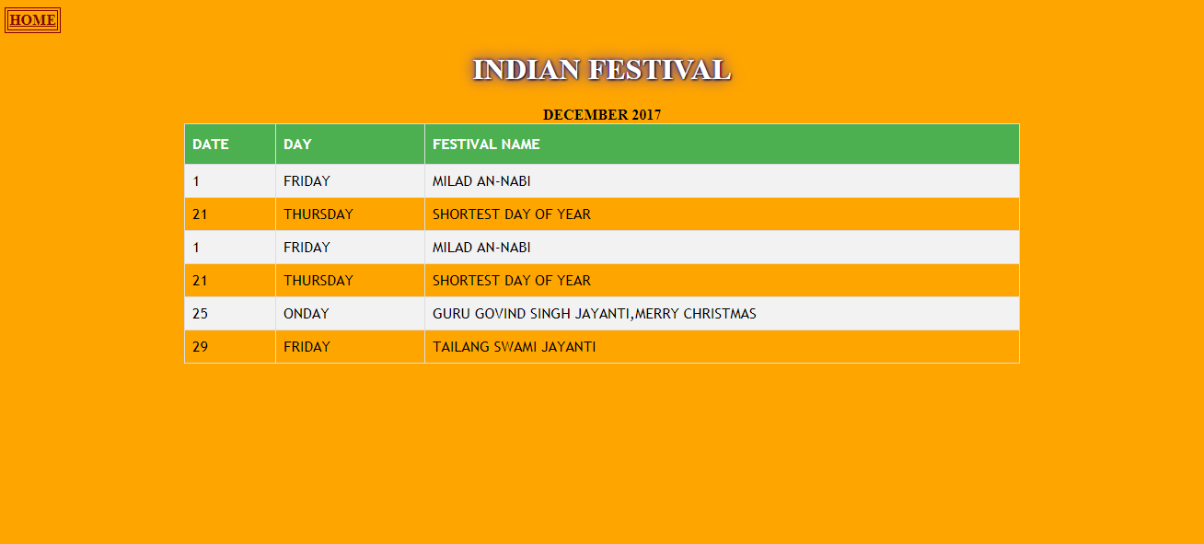

DECEMBER

<html><head><title>indian calander</title></head>

<body bgcolor="orange">

<table border="1" bordercolor="#800000"><tr><th><a href=" HOME PAGE.html"><font color="800000" size="3">HOME</th></tr></table>

<center><html><head><style>

h1 {

color: white;

text-shadow: 1px 1px 2px black, 0 0 25px blue, 0 0 5px darkblue;

}

</style></head>

<body><h1>INDIAN FESTIVAL</h1><b><center><html><head><style>

#customers {

font-family: "Trebuchet MS", Arial, Helvetica, sans-serif;

border-collapse: collapse;

width: 70%;

}

#customers td, #customers th {

border: 1px solid #ddd;

padding: 8px;

}

#customers tr:nth-child(even){background-color: #f2f2f2;}

#customers tr:hover {background-color: #ddd;}

#customers th {

padding-top: 12px;

padding-bottom: 12px;

text-align: left;

background-color: #4CAF50;

color: white;

}

</style>

</head>

<body>

<center> DECEMBER 2017</CENTER>

<CENTER><table id="customers" WIDTH="50%">

<tr><th>DATE</th>

<th>DAY</th>

<th>FESTIVAL NAME</th>

</tr><tr><td>1</td>

<td>FRIDAY</td>

<td> MILAD AN-NABI</td>

</tr><tr>

<td>21</td>

<td>THURSDAY</td>

<td> SHORTEST DAY OF YEAR</td>

</tr><tr>

<td>1</td>

<td>FRIDAY</td>

<td> MILAD AN-NABI</td>

</tr>

<tr>

<td>21</td>

<td>THURSDAY</td>

<td> SHORTEST DAY OF YEAR</td>

</tr>

<tr>

<td>25</td>

<td>ONDAY</td>

<td> GURU GOVIND SINGH JAYANTI,MERRY CHRISTMAS</td>

</tr><tr>

<td>29</td>

<td>FRIDAY</td>

<td>TAILANG SWAMI JAYANTI</td></tr> </table>